**Notes:**

* You are required to upload your implementations of problems 1 and 2 to canvas. This is due by 7:59 AM on Wednesday, Dec 05, 2018.

**Objective:**

* Implement Dijkstra’s Algorithm to find the single source shortest paths for a directed graph.

**Problems:**

1. Implement Dijkstra’s algorithm using pseudocode algorithm.
2. Write a driver program, which reads input files tinyDG.txt, mediumDG.txt, largeDG.txt and XtraLargeDG.txt (downloadable from Canvas) and run Dijkstra’s algorithm on each of them to find the Single Source Shortest Path within these graphs considering 0 as the source. Record the times required for each of these graphs.

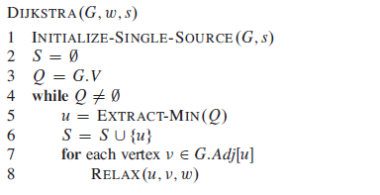

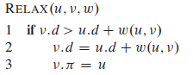

initialize_single_source( Graph g, Node s )

for each vertex v in Vertices( g )

d[v] := infinity

pi[v] := nil

d[s] := 0;